BudTrack: An Expense Tracker

Guided by:

Prof. Bhakti Raul

Submitted by:

1811022 : Aaditya Mahadevan

1811031 : Krish Parekh

**Abstract**

This report specifies the various processes and techniques used in designing, implementing and testing for the project on an expense manager , built as a desktop application using Python. The features of the current available expense managers were analyzed and referred to.

BudTrack comes under the category of ‘desktop application’ i.e. it is a simple program that can be run on your laptop/PC without needing to use a browser.

Thus this application aims at providing similar basic features in a simple and easily understandable form.

Contents

1. **Introduction**

1.1Identification

1.2 Purpose

1.3 Scope

1.5 Overview and Restrictions

1. **Overall Description**

2.1 Product Perspective

2.2 Product Features

2.3 User Classes and Characteristics

2.4 Operating Environment

1. **Python Functionalities**

3.1 Basic Python

3.2 GUI Programming with Tkinter

3.3 Database Access

1. **Screenshots of the System**
2. **Link to User Manual**
3. **Conclusion**
4. **References**

# **Introduction**

An expense tracker is a software or application that helps to keep an accurate record of your money inflow and outflow.

**Identification**

The desktop application being considered for development is referred to as BudTrack.

The end users of these applications will be people who need help managing their finances.

As this is the first project in its development , the version under development is version 1.0.

**Purpose**

The purpose is to design desktop applications providing functionalities of a basic expense tracker like adding/deleting budgets, expenses and to view the same in a chart format.

A login and signup system has been added with the help of a database management system to make the application more secure and store information about each user efficiently.

**Scope**

As BudTrack is developed as a desktop application only, so the scope is limited to the desktops and not as a web application. At a time only one person can log into the system and view or edit his finances.

**Overview**

Section 2 of this document describes the application under development from a holistic point of view. Functions ,characteristics, assumptions, dependencies and overall requirements are defined from application-level perspective.

Section 3 of this document describes the interfaces of the application being developed. They

Include the resources used to develop the application.

Section 4 of this document contains the screenshots of the desktop application. This chapter also contains the link to the user manual for further help.

Section 5 of this document contains a link to the user manual for the desktop application which guides the user through the installation process and explains the features of the application.

Section 6 of this document concludes the whole desktop application.The main aim of the conclusion is to restate the main argument. It reminds the reader of the strengths of main argument(s) and reiterates the most important evidence supporting those argument(s).

Section 7 of this document contains the references used while building this application and to give credit to the writers from whom you have borrowed words and ideas.

# **Overall Description**

This chapter provides an overall description of the desktop application.

**Product Perspective**

The product is an expense tracker for Windows OS with the capabilities to add/delete budgets and expenses and keep a track of them easily.

**Product Features**

BudTrack provides the following functionalities:

1.**Login/Register**

In computer security, logging in (or logging on, signing in, or signing on) is the process by which an individual gains access to a computer system by identifying and authenticating themselves. The user credentials are typically some form of "username" and a matching "password", and these credentials themselves are sometimes referred to as a login.

**Operations:**

* Login
* Create Account

2. **Expense Tracker**

Expense tracker is a simple way to manage your spending and earnings.

**Operations:**

* **Budget:** Basic operations include:

1. Add Amount
2. Delete Amount
3. Sort By Amount
4. Sort By Date
5. Delete selected entry
6. Delete all entries
7. Logout

* **Expense**: Operations include the following functions:

1. Add Item
2. Delete Item
3. Sort By Item
4. Sort By Amount
5. Sort By Date
6. Delete selected entry
7. Delete all entries
8. Logout

* **Graph**: View your budget and expenses as a pie chart indicating the money spent and money left

1. Graph It!
2. Logout

* **Logout** : Logout of the application once you have finished adding/deleting/viewing your account details.

**User Classes and Characteristics**

The users of BudTrack are those who want to keep a track of the cash inflow/outflow or document the expenses they have made.

**Operating Environment**

The operating environment of BudTrack are listed below:

* Operating System : Windows
* Database : sqlite3
* Front-end : Tkinter (Python Module)
* Backend : Python

# **Python Functionalities**

This section includes the python resources used to develop the desktop application.

**Basic Python**

Python is an interpreted, object-oriented, high-level programming language with dynamic semantics. Its high-level built in data structures, combined with dynamic typing and dynamic binding, make it very attractive for Rapid Application Development, as well as for use as a scripting or glue language to connect existing components together. Python's simple, easy to learn syntax emphasizes readability and therefore reduces the cost of program maintenance. Python supports modules and packages, which encourages program modularity and code reuse. The Python interpreter and the extensive standard library are available in source or binary form without charge for all major platforms, and can be freely distributed

**GUI Programming - Tkinter**

Tkinter is the standard GUI library for Python. Python when combined with Tkinter provides a fast and easy way to create GUI applications. Tkinter provides a powerful object-oriented interface to the Tk GUI toolkit.

Creating a GUI application using Tkinter is an easy task. All you need to do is perform the following steps −

* Import the *Tkinter* module.
* Create the GUI application main window.
* Add one or more of the above-mentioned widgets to the GUI application.
* Enter the main event loop to take action against each event triggered by the user.

**Tkinter Widgets**

Tkinter provides various controls, such as buttons, labels and text boxes used in a GUI application. These controls are commonly called widgets.

There are currently 15 types of widgets in Tkinter.

**Database Access**

The Python programming language has powerful features for database programming. Python supports various databases like MySQL, Oracle, Sybase, PostgreSQL, etc. Python also supports Data Definition Language (DDL), Data Manipulation Language (DML) and Data Query Statements. For database programming, the Python DB API is a widely used module that provides a database application programming interface.

**Benefits of Python for database programming**

There are many good reasons to use Python for programming database applications:

* Programming in Python is arguably more efficient and faster compared to other languages.
* Python is famous for its portability.
* It is platform independent.
* Python supports SQL cursors.
* In many programming languages, the application developer needs to take care of the open and closed connections of the database, to avoid further exceptions and errors. In Python, these connections are taken care of.
* Python supports relational database systems.
* Python database APIs are compatible with various databases, so it is very easy to migrate and port database application interfaces.

# 

# **Screenshots of the System**

Following are the screenshots of BudTrack , our desktop application:

1. Login

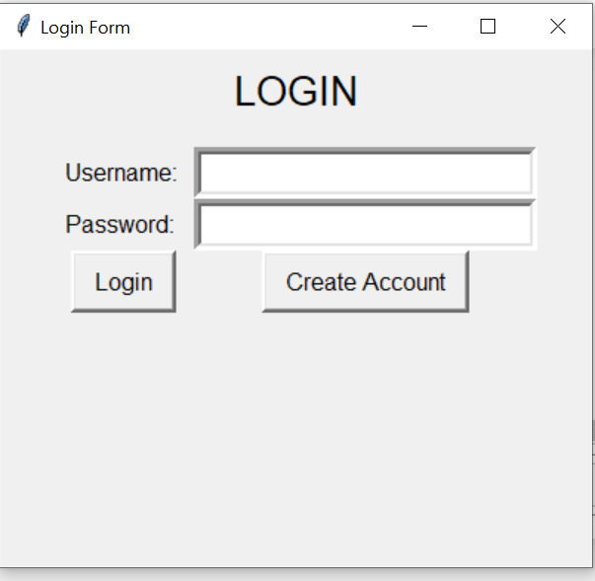

1. Register

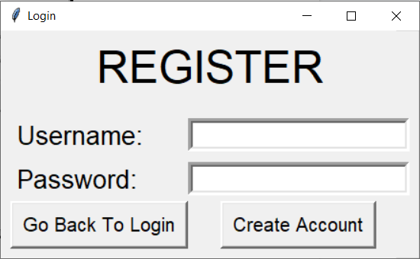

1. Budget

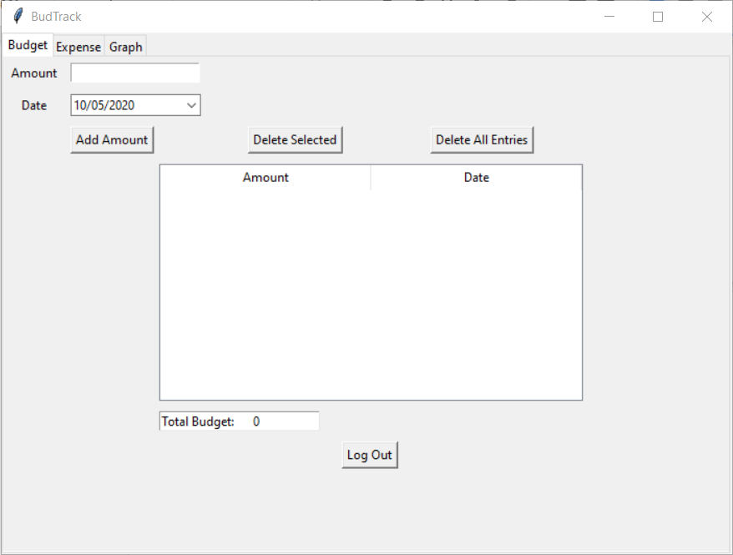

1. Expense

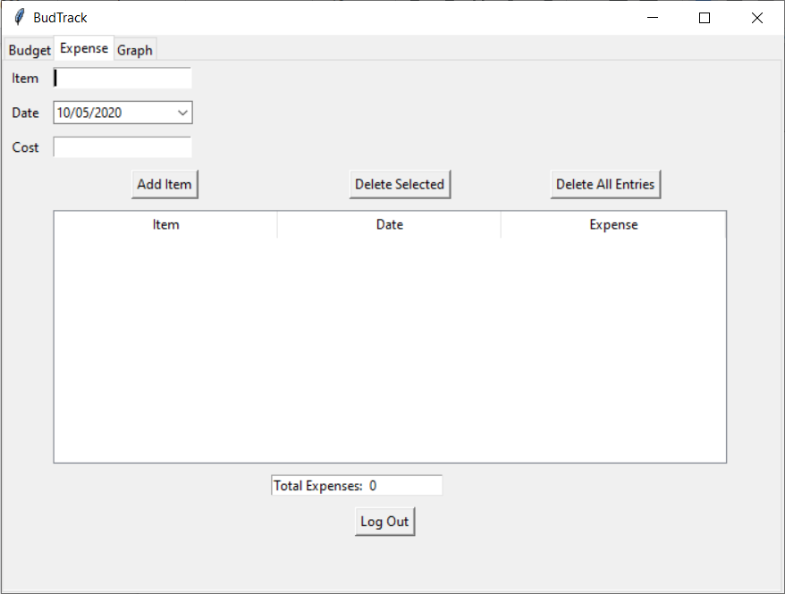

1. Graph

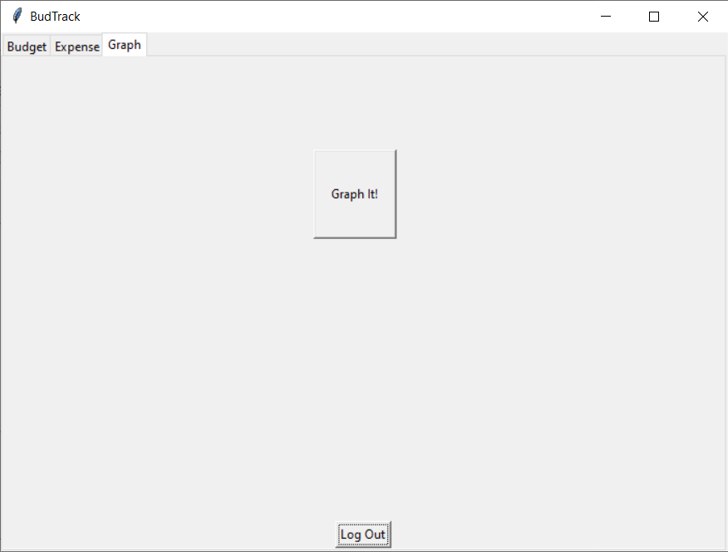

# 

# 

# 

# **Link to User Manual**

For a detailed description of various functionalities please refer the following link to the user manual:

[BudTrack User Manual](https://docs.google.com/document/d/1ans8Ny1CYTYWcibBFQQhe1XNt10M3rmrC1QiLG0lXzQ/edit#)

# **Conclusion**

BudTrack , an expense tracker was developed with the help of python with various different functionalities which are easy to interpret for the user.

Thus while developing this we gained experience about Python, database connectivity with python using sqlite3 and GUI using Tkinter.

# 

# References

1. [Wikipedia, the free encyclopedia](https://en.wikipedia.org/)
2. [GeeksforGeeks | A computer science portal for geeks](https://www.geeksforgeeks.org/)
3. [https://www.tutorialspoint.com/](https://www.tutorialspoint.com/index.htm)
4. [Stack Overflow - Where Developers Learn, Share, & Build Careers](https://stackoverflow.com/)
5. <https://www.youtube.com/>